# Repeated Measures ANOVAs

An experiment ran the classic mental rotation task (Shepard & Metzler, 1971) to see how long someone would take to mentally rotate objects. Each subject was presented with two pictures, and they were asked to indicate if the objects were the same or different. The manipulation was the amount of rotation (45, 90, 180 degrees in our dataset). Is there a significant impact of rotation on the time to decide if objects are the same?

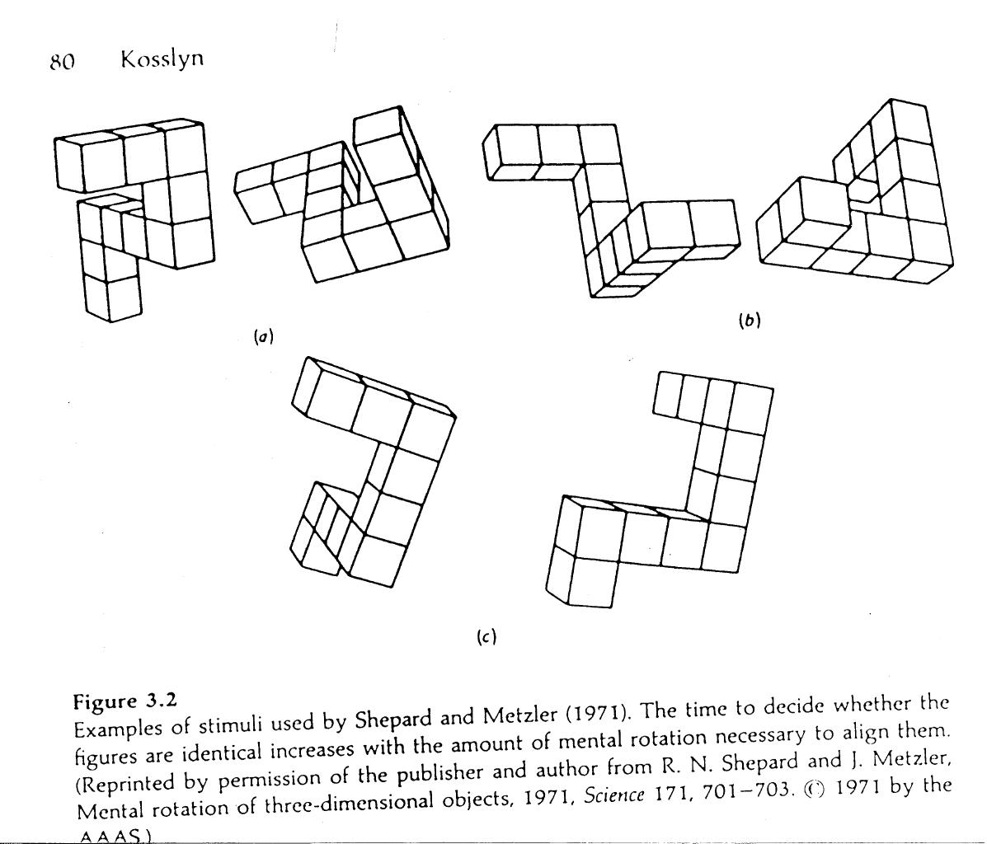

IV: Rotation: 45, 90, 180

DV: time to guess at objects (times are listed in seconds).

Data screening: Please include a relevant picture or information (like Mahalanobis scores/cut offs) for each of the following:

1. Accuracy – the max time allowed was 6 seconds, anything over 6 seconds was counted as 6 seconds.
2. Outliers
3. Normality
   1. Skew/Kurtosis
4. Linearity
5. Homogeneity
6. Sphericity

What is the critical F-value for this test at alpha = .05?

Run this ANOVA in SPSS. Paste the appropriate ANOVA box.

Paste the box with the means for each group.

Run a post hoc analysis to figure out which rotations were significantly different from each other. There are several ways to analyze this data, but include the boxes from your analysis (post hoc box, t-test box, etc.).

Calculate the Cohen’s d values for each post hoc analysis and list below (use the online chart, but make sure you use the right tab). You will include these values in your write up.

IN A SEPARATE WORD DOCUMENT:

Write up a results style section for this experiment.

1. Include a brief description of the experiment and variables.
2. Include a brief section on the data screening/assumptions.
3. Include the overall omnibus test results.
4. Include the post hoc results from follow up tests (remember, effect sizes!).
5. Include a figure of all the means (be sure to make sure you go back and check what is required for the figure).